**Course: Advance Bio Informatics**

**Module Title: DNA Profile**

**Module No: 110**

**DNA Profile**

* Encrypted sets of numbers that reflect a person's DNA makeup,
* Variable number tandem repeats (VNTRS).
* Short term tandem repeats (STR) in making the DNA profile of a person.
* These DNA profiles are the basis of a national DNA databases.

**DNA profiling processes**

* RFLP analysis.
* PCR analysis.
* STR analysis.
* Amp FLP.
* Y-chromosome analysis.

**Restriction Fragment length Polymorphism (RFLP)**

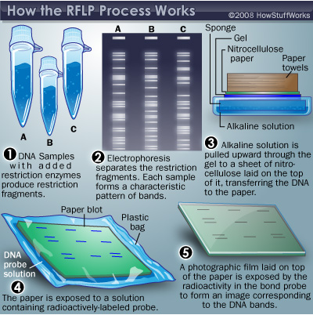

**RFLP**

* It analyzes the length of strands of DNA that include repeating base pairs (VNTRs).
* Repeated sequence of human genome can be same but the number of times it is repeated is unique to everyone.

RFLP analysis requires investigators to dissolve DNA in an enzyme that breaks the strand at specific points.

The number of repeats affects the length of each resulting strand of DNA.

Investigators compare samples by comparing the lengths of the strands.

**Example:** CAT is repeated continuously 13 times in a row. In somebody else, it might be 12 times or 14 or whatever.

**Limitation**

RFLP analysis requires a fairly large sample of DNA that hasn't been contaminated with dirt.